**Jetson Re-flash procedure**

1. Install <https://docs.nvidia.com/sdk-manager/install-with-sdkm-jetson/index.html>  on ubuntu machine
2. Connect JetsonTx2 to host machine with the original USB-microUSB cable
3. Open SDK Manager on host machine (Target Hardware should detect inserted device). Press “Continue To Step2”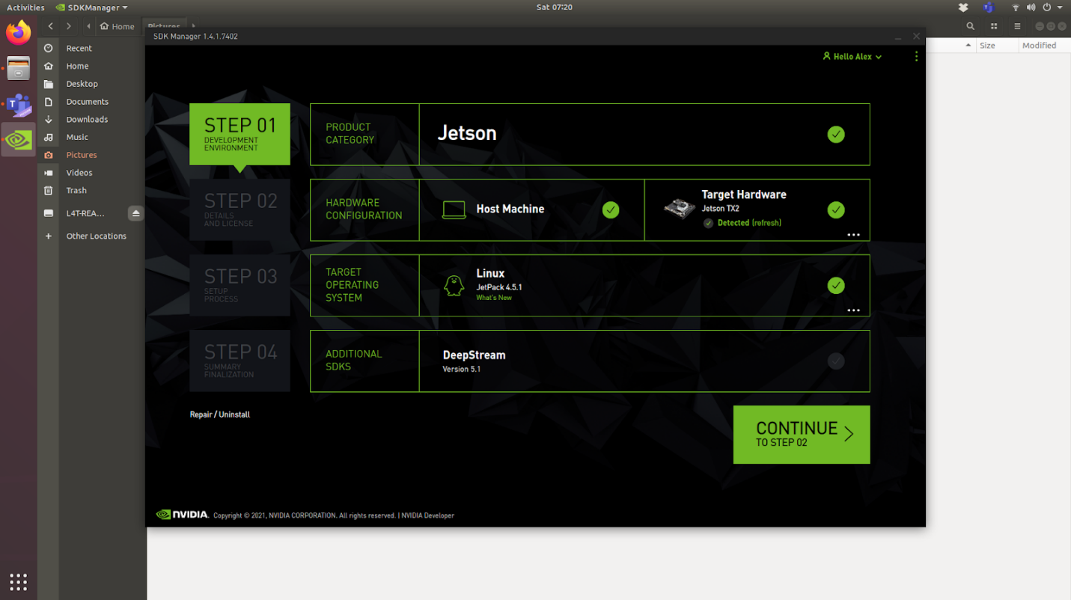
4. Click on “I accept the terms and conditions of the license agreement”. Click “Continue To Step 03”. You will be prompted to create /home/USER/nvidia/nvidia_sdk and /home/ USER /Downloads/nvidia/sdkm_downloads folders. Click “Create” for both. Enter root password when prompted. Wait for downloads to finish.

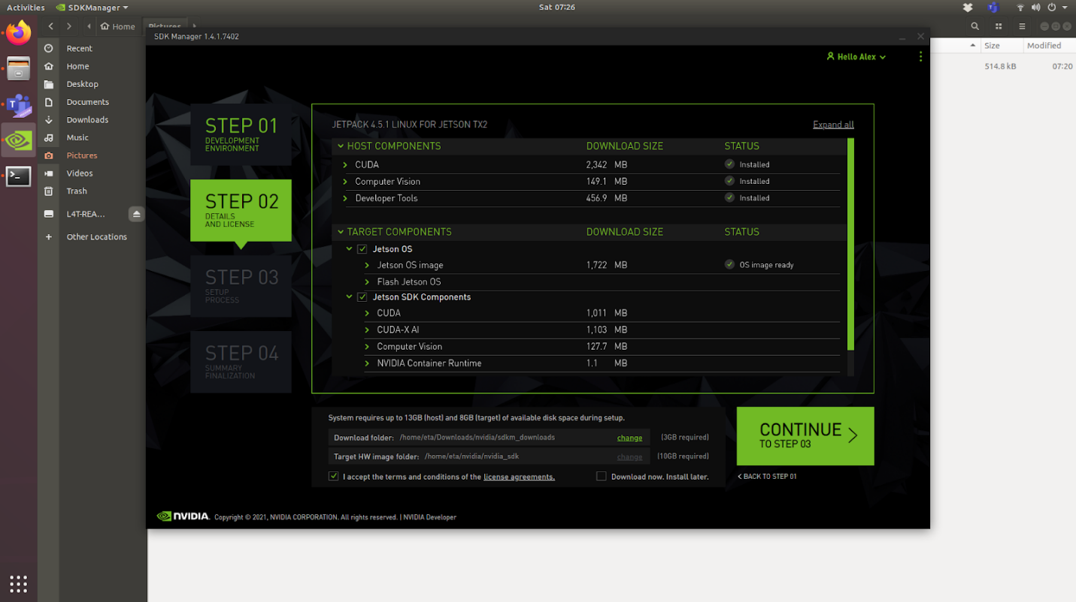

1. Insert current username and password and click “Flash”

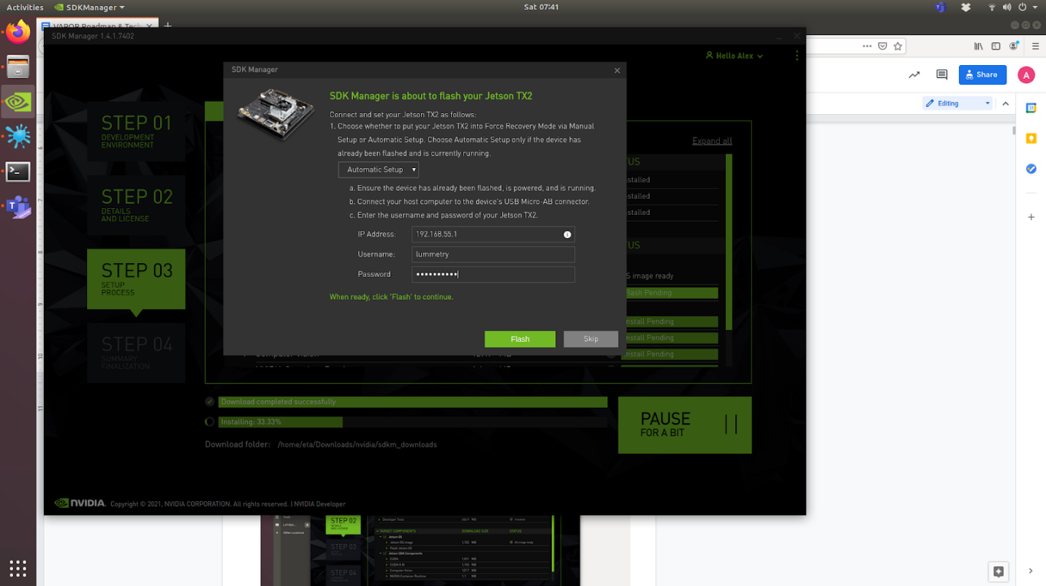

At this moment, the JetsonTx2 restarts in Recover mode and starts flashing the device: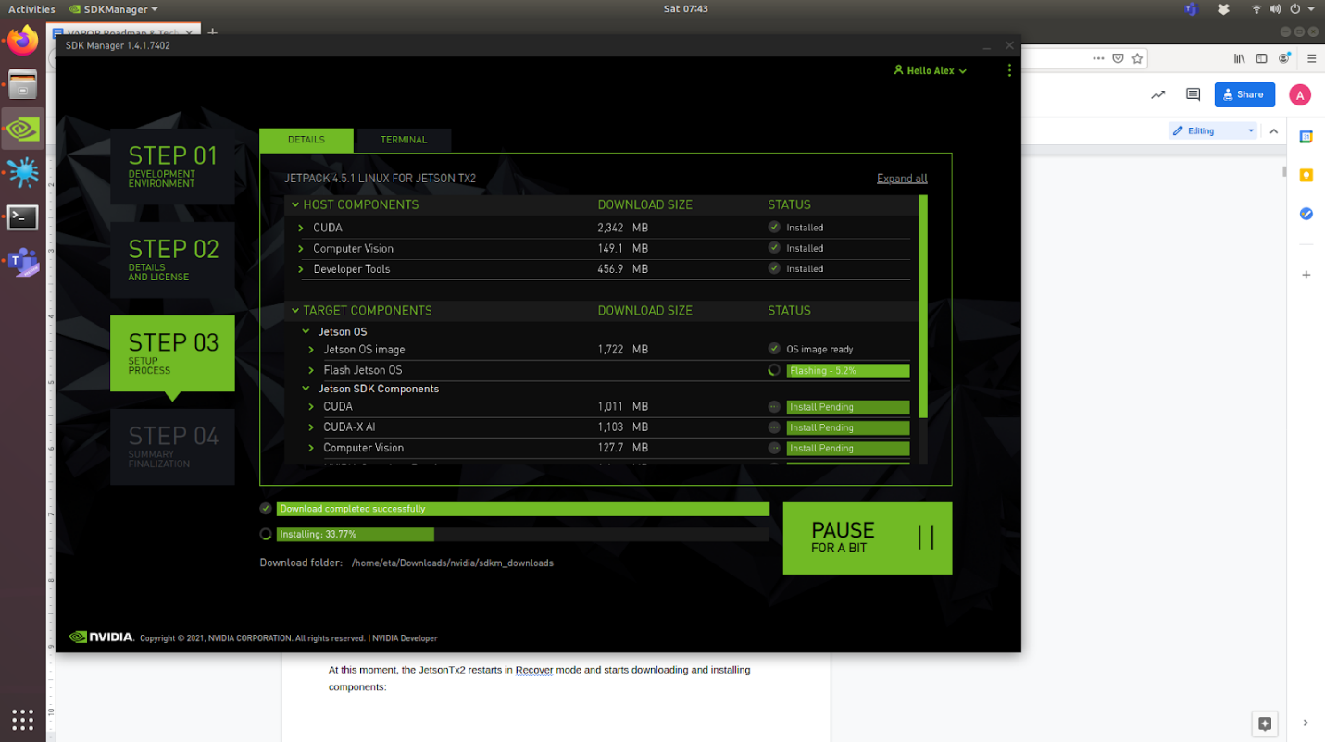

When the Flash ends, you will be able to complete the “System configuration wizard” on Jetson.

1. Complete the “System configuration wizard” on Jetson with default settings (English, etc.). The JetsonTx2 will restart automatically.
2. Login and connect JetsonTx2 to a network (lan/wifi)
3. On host machine, insert the username and password from your freshly installed Jetson. Click Install

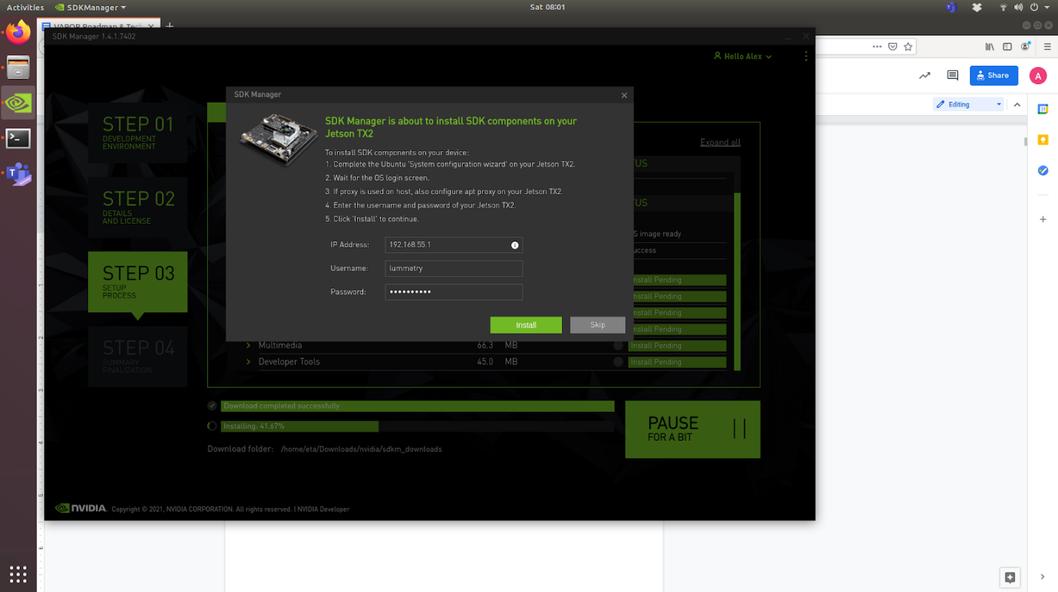

1. Wait for install process to finish. Click “Finish and exit”
2. Move on Jetson and start install Tensorflow, Pytorch, Torchvision
   1. TENSORFLOW

|  |
| --- |
| * sudo apt-get update * sudo apt-get install libhdf5-serial-dev hdf5-tools libhdf5-dev zlib1g-dev zip libjpeg8-dev liblapack-dev libblas-dev gfortran * sudo apt-get install python3-pip * sudo pip3 install -U pip * sudo pip3 install -U pip testresources setuptools==49.6.0 * sudo pip3 install cython * sudo pip3 install -U numpy==1.19.4 future==0.18.2 mock==3.0.5 h5py==2.10.0 keras_preprocessing==1.1.1 keras_applications==1.0.8 gast==0.2.2 futures protobuf pybind11 * sudo pip3 install --pre --extra-index-url https://developer.download.nvidia.com/compute/redist/jp/v45 tensorflow |

* 1. PYTORCH

|  |
| --- |
| * sudo apt-get install libopenblas-base libopenmpi-dev * download pip wheel from jetson zoo. For example Pytorch v1.8.0: https://nvidia.box.com/shared/static/p57jwntv436lfrd78inwl7iml6p13fzh.whl * cd Downloads * sudo pip3 install torch-1.8.0-cp36-cp36m-linux_aarch64.whl |

* 1. TORCHVISION

|  |
| --- |
| * sudo apt-get install libjpeg-dev zlib1g-dev * git clone https://github.com/pytorch/vision torchvision * cd torchvision * sudo python3 setup.py install |

* 1. OTHER DEPENDENCIES

|  |
| --- |
| * sudo pip3 install psutil |